Our SAIDI AGM 2013 was held at our Head Office (500 Kyalami Boulevard, Kyalami Business Park, Kyalami, Midrand), on the 17th July 2013 from 10:00 to 16:00.
This was the first time SAIDI was able to contact members around the country during an AGM!
Technology has made this close working relationship possible in order to achieve our goals of combating death on South African roads by excellent driving instruction where it starts - at the new driver stage.
This is vital for the growth of SAIDI for various reasons. We do not want our members to feel cut off and disconnected from SAIDI. We want to include every legal driving instructor around the country.
Together we will address the road fatality rate by professional driving instruction; learning to apply the actual law in our own driving; setting good examples when we train new drivers and also when we travel from one side of our own areas to another.
WESTERN CAPE
We Skype video-conferenced with Jirk Nel - our representative from Western Cape. He gave us a short description of his background and interests, which are community-based, and spoke of his intentions of expanding SAIDI in the Western Cape. We fully-support this.
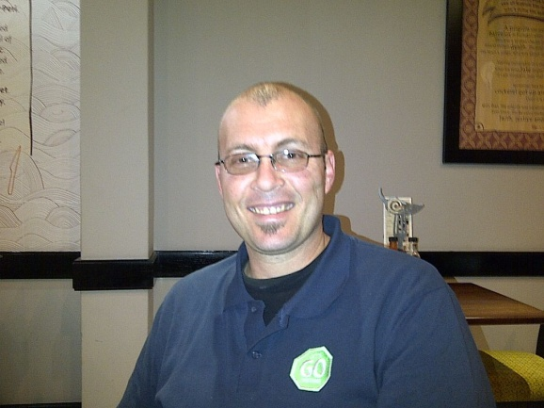

FREE STATE
We also video-conferenced with Chris Barnard, our representative from the Free State. He is doing a fine job in his area training on light motor vehicles and motor cycles. He chose to do it legally! He plans to try to include as many Free State instructors as possible, as soon as they become legal instructors too. His courtesy, appreciation of his fellowmen and women, his sense of humour and dedication to road safety really make him a fine example to all!
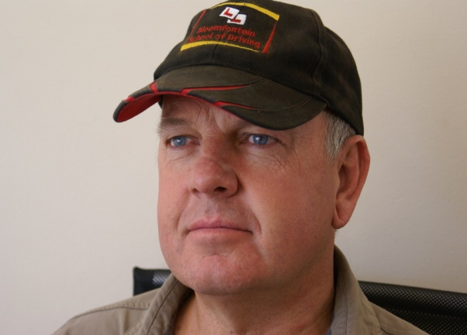

At the AGM we also Skype video-conferenced with Tecknotrove Systems (I) Pvt Ltd who wish to introduce their simulators to driving instructors in South Africa. Anyone who wishes to contact them may do so. Please contact us on Pat@saidinational.org. We will supply contact details.
Some other items under discussion at the AGM included:
- The finalization of our new Constitution;
- Various benefits of being a SAIDI member, such as company registration or sole proprietor registration; Affordability of membership;
- Members were invited to attend a free 3-day workshop at our Head Office in Kyalami Business Park, Midrand from Wednesday 24th July to Friday 26th July 2013 to study the National Road Traffic Act 93 of 1996, specifically Regulatory and Warning road signs, Guidance and Informative road signs, painted road markings; rules of the road; traffic signals.
SAIDI is growing! There used to be an idea that SAIDI was a white-based Institute, but that is definitely not the case now, if it ever was.
We recognise that the people dying in road fatalities in South Africa are not confined to any specific ethnic group. We want members from every cultural and language group in the country
Are you also a legal dedicated driving instructor? Consider joining us.
We wish to include every legal driving instructor in South Africa under our banner, right there where you work, to let your community know that you are available as a professional service provider who can meet their need for driving instruction in your area.
Feel free to email Pat@saidinational.org to arrange your Skype video conference, so that we can discuss your aims.
Together we can make a difference in South Africa for all South Africans!

